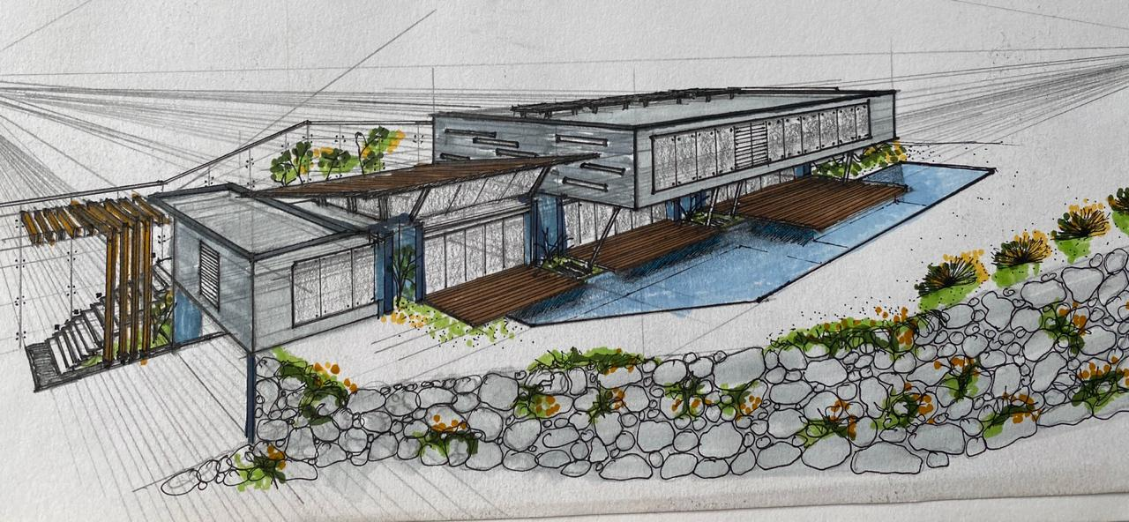

SPECIFICATIONS DRAGADOS TECH Hermosa Heights:
This luxury home is in a private condominium called "Hermosa Heights", located in Playa Hermosa in the province of Guanacaste. With a 180° view over the sea and the Papagayo Peninsula.
Overall, it has an area of 565 m2.

The residence as such, has an area of 484.10 m2, contemplating terrace and pool areas.
It consists of three levels that are broken down as follows:

• Basement, 168.90 m2.
Space to locate 2 to 3 vehicles.
Planned to build 2 rooms.
Machine room.
Service access for cleaning staff, both for the pool and green areas.
Internal staircase to enter the residence.
Internal patio that allows EXCELLENT natural lighting and ventilation in the basement.

• Level I, 206.15 m2.
Pedestrian access for visitors.
Entrance hall with ocean view.
Living / kitchen / dining room, all with exits to pool terrace and overlooking the sea.
Minibar, pantry, and access stairs to the second level.
A complete sanitary service for visitors or users of the residence.
Terraces and pool with sea view.
Patio.

• Level II, 109.05 m2.
Access staircase.
Two secondary bedrooms, one of them with sea view.
A shared sanitary service between these two secondary rooms.
A Master room, with full private sanitary service and closet with spectacular sea view.

